**Work Zone Data Collection**

**Mobile Application**

Technical Set up and Documentation

Table of Contents

Contents

1.1 Android Studio software 3

1.1.1 Android APK Supported Versions 4

Tested and deployed APK platforms: 4

1.1.2 SDK Tools 4

1.2 Device Requirements/Permissions 5

1.2.1 Location 5

1.2.1 Internet Access 5

1.3 Azure Connection 5

1.3.1 Azure Service Location 5

1.3.2 Azure Container 5

1.3.2 Azure Functions 5

1.4 Manual vs Automatic GPS 6

1.4.1 GPS detection 6

Internal GPS 6

USB GPS 6

1.6 Supported Devices 6

2.1 Install Application 8

Google Play Store 8

8

2.2 Main Page 8

2.3 Settings 9

2.4 Download Config Files 10

2.5 Map Work Zone – Configuration Page 10

2.5.1 Import configuration File 10

[2.4.2 10](https://neaera-my.sharepoint.com/personal/tony_neaeraconsulting_com/Documents/ICF/V2X/Tasks_5to7/WZDC%20Tool%20Mobile%20Application%20Setup%20+%20Documentation.docx#_Toc57106989)

2.5.2 GPS Selection 10

Internal GPS 10

[2.4.3 10](https://neaera-my.sharepoint.com/personal/tony_neaeraconsulting_com/Documents/ICF/V2X/Tasks_5to7/WZDC%20Tool%20Mobile%20Application%20Setup%20+%20Documentation.docx#_Toc57106992)

[2.4.1 10](https://neaera-my.sharepoint.com/personal/tony_neaeraconsulting_com/Documents/ICF/V2X/Tasks_5to7/WZDC%20Tool%20Mobile%20Application%20Setup%20+%20Documentation.docx#_Toc57106993)

USB GPS 10

2.5.3 Work Zone Type 11

2.5.4 Data Collection mode 11

2.7 Visualize Mapped Work Zone 13

2.8 Upload Path Data 13

1 Mobile application requirements

# 1.1 Android Studio software

The Work Zone Data Collection Tool (WZDC-Tool) mobile application is written with Android Studio version 4.0.1 and runtime version 1.8.0_242-release-1644-b01. The WZDC tool is written in Kotlin(version 1.3.73-release-Studio4.0-5) and uses the Gradle build system.

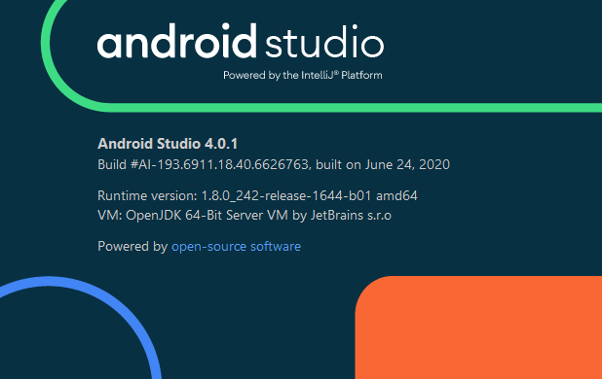

# 1.1.1 Android APK Supported Versions

The WZDC tool Android application supports multiple Android APK platforms and SDK Tools.

## Tested and deployed APK platforms:

* API version: 29 (Android 10.0+(R))
* API Version: 30 (Android 10.0(Q))

## 1.1.2 SDK Tools

* Android SDK Build-Tools
* Android Emulator (for local development – optional)
* Android Emulator Hypervisor Driver for AMD Processors(optional)
* Android SDK Platforms-Tools
* Google Play services
* Google USB Driver

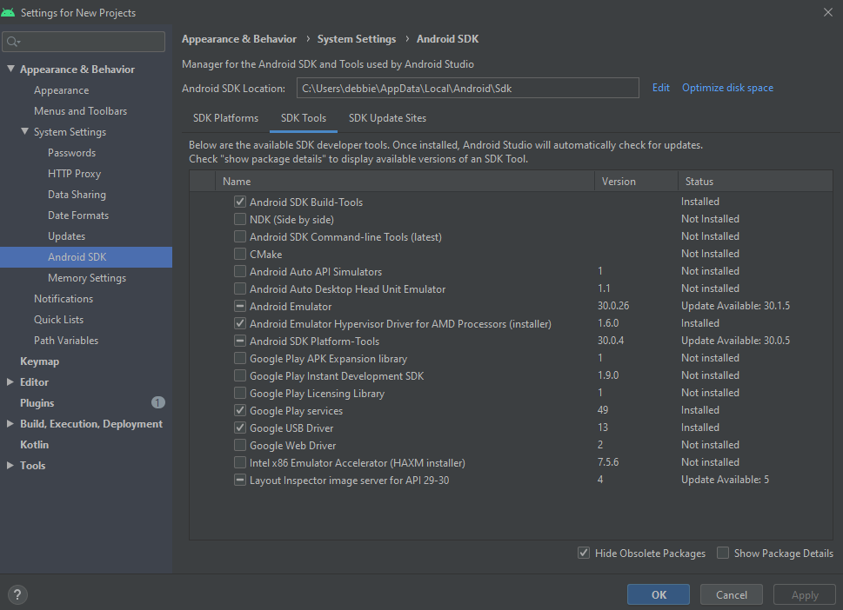

# Device Requirements/Permissions

## 1.2.1 Location

The WZDC Tool required the mobile device to have location services enabled before allowing the user to create a work zone data collection file. When the application opens the user will be prompted to turn on location services if it is off. The application will also request the user to allow or deny the use of the location before allowing the user to drive and collect data for the work zone data collection.

## 1.2.1 Internet Access

The mobile phone must have access to the internet to receive information for:

* Downloading configuration files
* Uploading collected work zone map data (csv file)

*Future release will allow a user to map the work zone offline and upload later

## 1.3 Azure Connection

The WZDC Tool uses an MS Azure backend to host the configuration files, WZDx and RSM files. To gain access to this environment a specific account name and account key are required. To gain access to this information, please email [tony@neaeraconsulting.com](mailto:tony@neaeraconsulting.com) for this.

## 1.3.1 Azure Service Location

Configuration files, WZDx and RSM messages are stored in a MS Azure Storage Account. To request access to this information, please email [tony@neaeraconsulting.com](mailto:tony@neaeraconsulting.com).

## 1.3.2 Azure Container

* archived and in progress configuration files
* work zone uploads

## 1.3.2 Azure Functions

We have 2 Azure functions that run

* generate-messages – When a CSV file is uploaded to the *workzoneuploads* container
* ingest-unzip – When a ZIP archive is uploaded to the *workzonedatauploads* container

The generate-messages function is described in the WZDC Tool Documentation Updates document, located <https://github.com/TonyEnglish/V2X_MobileApplication/blob/master/Documentation/WZDC%20Tool%20Documentation%20Updates.pdf>.

The ingest-unzip function unzips an upload archive and organizes the contents into sub-directories within the *unapprovedworkzones* container.

## 1.4 Manual vs Automatic GPS

The WZDC tool can capture path data in two ways, using the internal GPS from the mobile phone or capturing data from an external GPS. Depending on the frequency of the capturing of the data, it will determine if an RSM message can be generated.

## 1.4.1 GPS detection

### Internal GPS

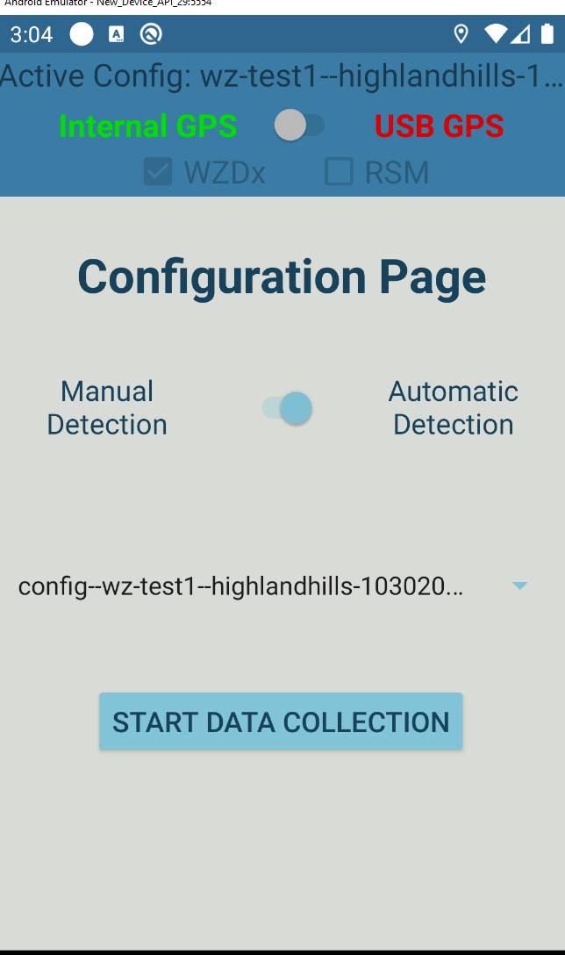

* Status is disconnected if the internal location service is not enabled
  + Location permissions not granted
* Status is invalid if no GPS coordinates have been received for at least 4 seconds.
  + Location is disabled
  + Internal GPS is malfunctioning
* Status is valid if internal location service is enabled and location is enabled

### USB GPS

* Status is disconnected if no USB devices are connected
  + Device is not connected
  + Device is not supported (rare)
* Status is invalid if no GPS coordinates have been received for at least 4 seconds.
  + GPS Signal was lost
  + Device is malfunctioning (rare)
* Status is valid if a valid GPS fix is received from the GPS

*Note: Status is re-evaluated every 4 seconds

*Note: Valid GPS Fix requires DateTime, latitude, longitude, altitude, HDOP, speed and heading. This can take a long time to establish for devices that are obscured (inside buildings) or stationary

## 1.6 Supported Devices

The WZDC Tool was tested and developed for several Android mobile devices.

* Device Requirements
  + Minimum Android Version: Marshmallow (Android v6.0), API 23
  + Maximum Android Version: Android 11, API 30
* Tested Devices
  + Oneplus 6T, OxygenOS v10.3.6
  + Samsung S8, Android v9.0
  + LG Aristo, Android v7.1.2
  + Samsung Galaxy Note 10, Android v10.0
  + Tony’s Phone
  + Samsung Galaxy S10E, Android v10.0

External (USB) GPS

* Device Requirements
  + Serial Output: NMEA v2.3
  + Data Rate: 1-10 Hz
  + Accuracy
    - < 2m for RSM + WZDx message generation
    - > 2m for only WZDx message generation
* Tested Devices
  + VK-162 G-Mouse USB GPS
  + U-Blox EVK-M8N-0 (Part# 672-1056-ND)

Internal GPS

RSM

* RSM messages are only generated if every collected datapoint has a horizontal accuracy (HDOP) < 2 meters
* If ANY data point has an accuracy > 2 meters, RSM messages will not be downloaded

2 Application Details

The WZDC Tool mobile applications initially was created to allow the user to capture work zone data collection with few hardware requirements.

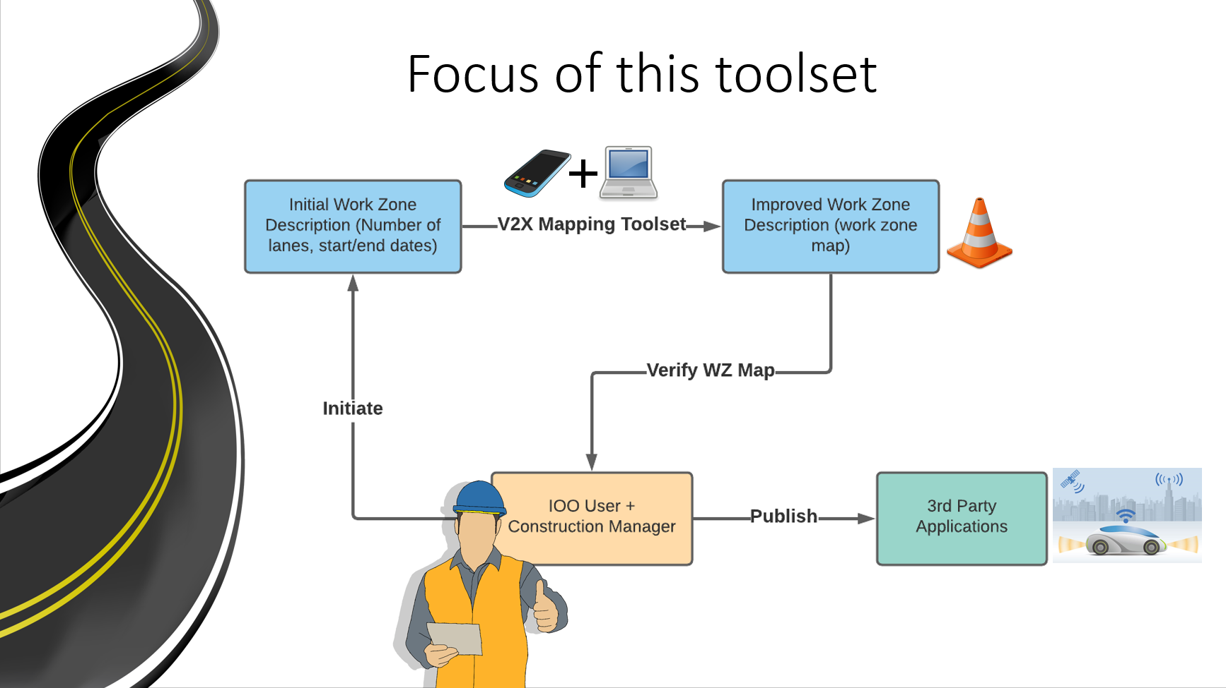

## 2.1 Install Application

## Google Play Store

Install

## 

## 2.2 Main Page

The firs page that loads is the main page. This page allows the user to manage configuration files, data files, map and visualize work zones, and change application settings. The logic determining when certain functions are allowed is listed below

* The **Download Configuration Files** button will be enabled if the device has an internet connection.
* The **Upload Data Files** button will be enabled if data files are present on the device and if the device has an internet connection
* The **Map Work Zone** button will be enabled if valid Azure Credentials have been entered
* The **View Work Zone** button will be enabled if data files are present on the device
* The **Settings** button will always be enabled

## 2.3 Settings

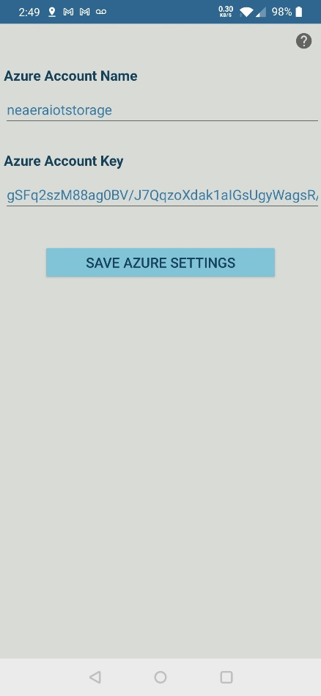The settings page contains the Azure required information to allow a user access to the Map Work Zone data collection part of the application. To receive this information, please contact [tony@neaeraconsulting.com](mailto:tony@neaeraconsulting.com) to get these values. Once the information has been entered and the users clicks SAVE, the information will be verified and notify the user if the information is incorrect. The Map Work Zone option will be made enabled once the connection has been established. This information is saved on the mobile device in the user preferences. If the application is uninstalled this information will need to be re-entered.

## 2.4 Download Config Files

Mapping a work zone requires that the corresponding configuration file is downloaded. This file contains basic information such as the number of lanes and the driven lane during data collection.

Configuration files must be downloaded before the start of data collection. This is done through the Download Config Files page. Simply select the config files that you would like to download and press sync. All local config files will be deleted when new config files will be downloaded.

## 2.5 Map Work Zone – Configuration Page

### 2.5.1 Import configuration File

### 2.4.2

Configuration files are located in the dropdown list on this page. These are the published configuration files that were created on the Work

### 2.5.2 GPS Selection

### Internal GPS

### 2.4.3

* Status is disconnected if the internal location service is not enabled
  + Location permissions not granted

### 2.4.1

* Status is invalid if no GPS coordinates have been received for at least 4 seconds.
  + Location is disabled
  + Internal GPS is malfunctioning
* Status is valid if internal location service is enabled and location is enabled

### USB GPS

* Status is disconnected if no USB devices are connected
  + Device is not connected
  + Device is not supported (rare)
* Status is invalid if no GPS coordinates have been received for at least 4 seconds.
  + GPS Signal was lost
  + Device is malfunctioning (rare)
* Status is valid if a valid GPS fix is received from the GPS

*Note: Status is re-evaluated every 4 seconds

*Note: Valid GPS Fix requires DateTime, latitude, longitude, altitude, HDOP, speed and heading. This can take a long time to establish for devices that are obscured (inside buildings) or stationary

### 2.5.3 Work Zone Type

Map zone data collection has 2 modes available as defined in graphic below. In Manual mode, all options are manually set by the user. In automatic mode, the start and end points are automatically set, and lane closures and workers present are manually set by the user.

### 2.5.4 Data Collection mode

#### 2.5.4.1 Manual

For manual work zone data collection this will require you to manually select all the work zone features. The following figure represents the options that are available to mark will in data collection mode.

#### 2.5.4.1 Automatic

For automatic work zone data collection this will require the user to manually set the lane closure and workers present only. The data collection will automatically start and end when the vehicle enters or exits the geofence location.

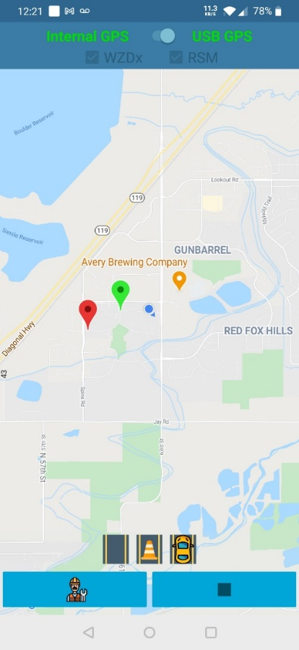2.6 Map Work Zone – Data Collection Page

Data collection functions slightly differently in manual and automatic detection modes. The application behavior is described below

1. In automatic detection mode (default), data collection will automatically commence when a set starting location is reached (from configuration file). Data collection will commence as normal, until the set ending location is reached, at which point data collection will end and the data file will be uploaded.
2. In manual detection mode, the user manually starts and ends data collection. When the user is approaching a work zone, the user presses the play button. When the work zone begins, the user presses the marker button. Then, data collection commences as normal. Once the user exits the work zone, they will press the stop button.

The user is (usually) required to drive in a specific lane, except in cases where the user does not intend to generate RSM messages. This lane is set in the configuration file and shown in the data collection screen by a car icon.

Once data collection has begun, the user can mark lane closures and the presence of workers. Lane closures are marked at the beginning of the taper. For a closing lane, mark the lane closed when the lane starts to taper to closed. For an opening lane, mark the lane open when the lane starts to taper to open. To mark a lane closure in the application, simply click the corresponding lane button. A cone will appear, signifying that the lane is closed. To open that lane, simply press the lane again. The lane with a yellow/orange car displays the lane that the user is driving in and cannot be closed. Images are shown below To mark workers present, press the worker button at the bottom. The background will change color and the worker will be colored in, signifying that workers are present. To mark workers no longer present, simply press the worker button again. Images are shown below

|  |  |  |
| --- | --- | --- |
| **Nothing Selected** | **Lane Closed** | **Workers Present** |
|  | Collect Path Data | Collect Path Data |

## 2.7 Visualize Mapped Work Zone

Immediately after a work zone is mapped, a visualization will be generated. Visualizations may also be loaded from the main page, by pressing the **View Work Zone** button. This button will only be enabled if work zone maps are present on the device (have not been uploaded). This will load a list of locally mapped work zones, from which a user can select one and press Visualize.

This visualization shows the recorded path data (small purple dots), Lane closure start/end markers (orange and blue markers showing the affected lane number), and start/end markers for the presence of workers (orange and blue markers with a W). The White R marker shows the start of the work zone.

## 2.8 Upload Path Data

After mapping a work zone, a data file will be saved to the device. A new data file is created for each distinct mapped work zone. These must be manually uploaded. This is done from the main page, by pressing the **Upload Data Files** button. This button will only be enabled if work zone maps are present on the device.

All of the data files will be pre-selected. Simply press a list item to toggle its selection. There are Select All and Deselect All buttons at the top. To upload all selected data files, simply press the Upload button at the bottom of the screen. Uploaded data files will be removed from the device and can no longer be visualized locally.

The next step is to move to the verification page of the associated website, <https://neaeraconsulting.com/V2X_Verification>. This page allows advanced visualization of work zones, as well as editing and publishing.